**Touch**

**Typing**

**Class Five**

**Lab 14**

|  |
| --- |
| Lab Objectives:  * Introducing Punctuation   ,   .   ;   ?   -  (    )  {  }  [  ]  "  !   * TAB, SHIFT, CAPS LOCK |

# Exercises

## P u n c t u a t i o n - check the chart below for the correct finger position. The comma is next to M and the full stop to its right. Use the same fingers as you do for K & L. To type a capital letter as you have done before, or a special character such as brackets (  ) or hypen -

## do the following ... Hold the Right Shift Key for a Left Hand letter or character Hold the Left Shift Key for a Right Hand letter or character.

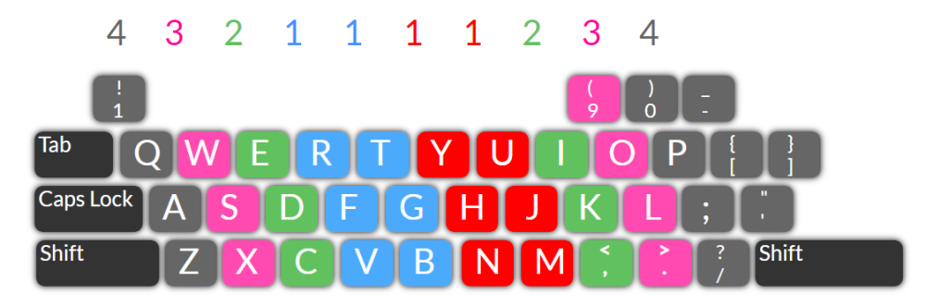

# Try these

## For the question mark, hold down the left Shift key while you type the / key.

## For the exclamation mark, hold down the right Shift key while you type the 1 key.

## The colon is on the semi-colon key and needs the left Shift key held.

## For the dash and for the hyphen use the same upper row key, between 0 and =

## The single quotation mark (beside the colon) is also used for the apostrophe.

# More Sentence Exercises

## Type the sentences below to practise your punctuation.

## If you practise your typing each day, it will soon become easy.

## Instead of a comma - you could use the dash - above the P key.

## Join for hyphen. First-class. Did you enjoy this typing course? I hope so!

## "Hullo," said Julia to George. "Isn't it a really lovely day?"

## "Stop! There's too much noise! It's giving me a headache!"

## Press down the Caps Lock (above the Left Shift key) for full capitals headings.

# Sentences with Brackets

Brackets. ( ) are above 9 and 0 - hold the Shift key while you type these.

## And these { } are beside P near the Shift key. { } P { } P { } P { } P { }

## Hold the {Shift} key while you type these { }.

## [ ] do not need the Shift key so are easier. [ ] Just [RIGHT] of the [P] key.

## They are on the same keys as { } to the right of [P].

## To Underline words first click the mouse on the U on the toolbar.

## You can also click on B for Bold, or I for Italics.